**ASSIGNMENT-5**

# OPEN-SOURCE TOOLS FOR IaaS:

1. **OpenNebula:**

OpenNebula is a flexible tool that orchestrates storage, network, and virtualization technologies to enable the dynamic placement of services on distributed infrastructures. OpenNebula provides a modular architecture intended to be flexible. One of these modules is the scheduler, an interesting algorithm that places virtual machines (VMs) depending on their requirements. The client communication is also managed by modules that offer interfaces based on web services. It is perhaps the only open management platform that has invested into a tailorable VM placement algorithm. As such, it may provide a nice environment for those researchers seeking to compare and develop different resource allocation strategies. A limitation found with the OpenNebula is that, like XCP, their infrastructure assumes a classical cluster-like architecture with a front-end and without any redundant services.

OpenNebula is an open-source management tool that helps virtualized data centres oversee private clouds, public clouds, and hybrid clouds. It combines existing virtualization technologies with advanced features for multitenancy, automated provisioning, and elasticity. A built-in virtual network manager maps virtual networks to physical networks. OpenNebula is vendor neutral, as well as platform agnostic and application programming interface (API) agnostic. It can use kernel-based virtual machine (KVM), Xen, or VMware hypervisor.

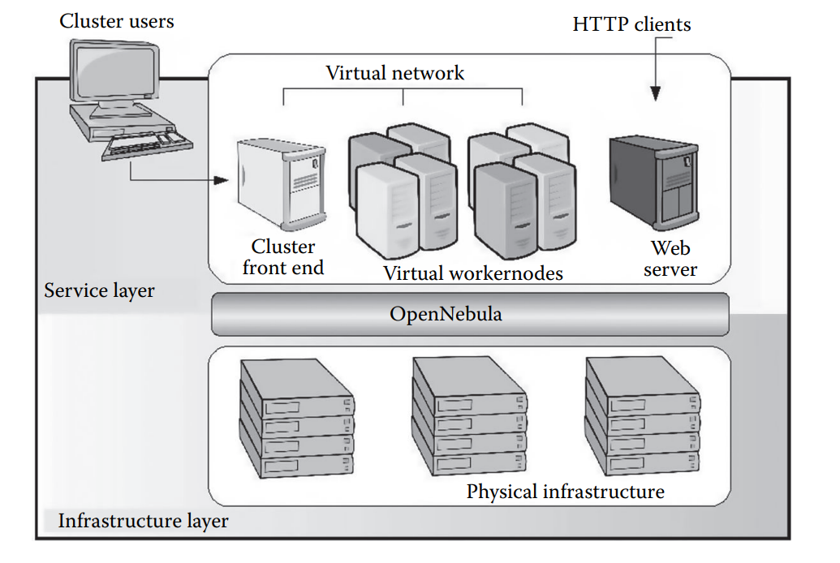

1. **Eucalyptus**

Eucalyptus implements IaaS-style private and hybrid clouds. The platform provides a single interface that lets users access computing infrastructure resources (machines, network, and storage) available in private clouds— implemented by Eucalyptus inside an organization’s existing data center— and resources available externally in public cloud services. The software is designed with a modular and extensible web services–based architecture that enables Eucalyptus to export a variety of APIs toward users via client tools. Currently, Eucalyptus implements the industry-standard Amazon Web Services (AWS) API, which allows the interoperability of Eucalyptus with existing AWS services and tools. Eucalyptus provides its own set of command line tools called Euca2ools, which can be used internally to interact with Eucalyptus private cloud installations or externally to interact with public cloud offerings, including Amazon EC2.

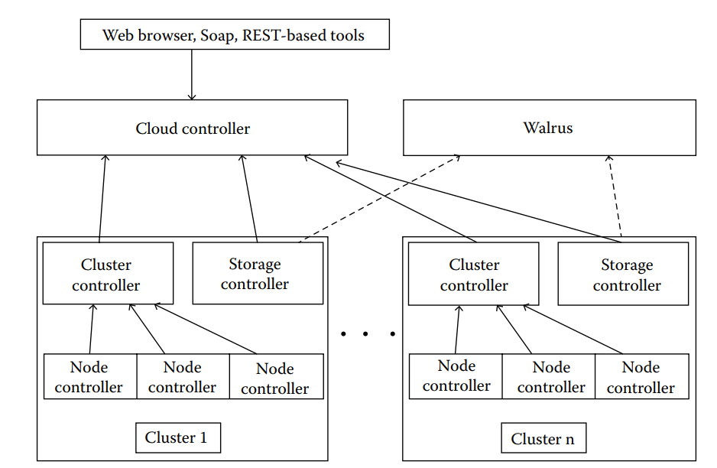

1. **OpenStack**

OpenStack, a cloud-computing project, aims to provide IaaS. It is a global collaboration of developers and cloud computing technologists producing the ubiquitous open-source cloud computing platform for building public and Web browser, Soap, REST-based tools Cloud controller Cluster controller Node controller Node controller Cluster 1 Cluster n Node controller Node controller Node controller Node controller Cluster controller Storage controller Storage controller Walrus FIGURE 12.2 Eucalyptus Cloud architecture. (Adapted from http://mdshaonimran.wordpress.com/2011/ 11/26/eucalyptus-and-its-components/.) Open-Source Support for Cloud 305 private clouds. It delivers solutions for all types of clouds by being simple to implement, massively scalable, and feature rich. The technology consists of a series of interrelated projects delivering various components for a cloud infrastructure solution. The goals of the OpenStack initiative are to support interoperability between cloud services and allow businesses to build Amazon-like cloud services in their own data centers. OpenStack, which is freely available under the Apache 2.0 license, is often referred to in the media as the Linux of the Cloud and is compared to Eucalyptus and the Apache CloudStack projects.

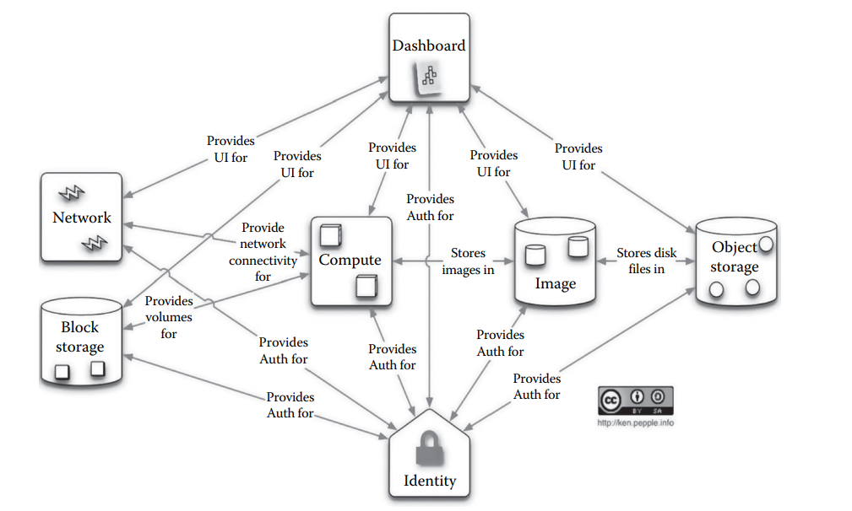

1. **Apache CloudStack**

Apache CloudStack is an open-source software designed to deploy and manage large networks of VMs, as a highly available, highly scalable IaaS cloud computing platform. CloudStack is used by a number of service providers to offer public cloud services and by many companies to provide an on-premises (private) cloud offering, or as part of a hybrid cloud solution. CloudStack is a better solution that includes almost all the features that most organizations expect from an IaaS cloud. It can be listed as follows:

• Compute orchestration   
• Network as a Service   
• User and account management   
• Full and open native API   
• Resource accounting   
• UI

# OPEN-SOURCE TOOLS FOR Paas

1. **PaasMaker**

Paasmaker is an open source PaaS. It provides full visibility to the users. Actions are broken down into trees that can be monitored all the time. It supports portability by offering interfaces for several common languages like PHP, Ruby, Python, and Node.js. Local development is made as one can run apps from a local directory. Plug-in-based architecture is very much suitable for extending the plug-ins. Paasmaker allows customization via plug-ins to easily extend the system in certain manners to offer additional services or runtimes. It is designed for the clusters. Paasmaker distributes work to multiple machines and monitors them. If a deployment fails, it is routed around automatically. If a controller node fails, the rest of the cluster stays up till it comes back.

1. **Red Hat**

OpenShift Origin is the open source upstream of OpenShift, the next generation application hosting platform developed by Red Hat. This is also known as Red Hat’s PaaS, OpenShift takes care of infrastructure, middleware, and management. OpenShift Origin includes support for a wide variety of language runtimes and data layers including Java EE6, Ruby, PHP, Python, Perl, MongoDB, MySQL, and PostgreSQL. OpenShift Origin platform has two basic function units: broker and node servers. Communication between these units is through message queuing service. The broker is the single point of contact for all application management activities. It is responsible for managing user logins, dynamic shutdown (DNS), application state, and general orchestration of the applications. Customers do not contact the broker directly; instead, they use the web console, command line interface (CLI) tools, or the JBoss Tools integrated development environment (IDE) to interact with the broker over a REST-based API. The node servers host the built-in cartridges that will be made available to users and the gears where user applications will actually be stored and served. MCollective client running on each node is responsible for receiving and performing the actions requested by the broker. OpenShift Origin supports several built-in cartridges based on the most popular app development languages and databases. In order for these to work, the underlying technology must be installed on every node server in an Origin system. A gear represents the slice of the node’s CPU, RAM, and base storage that is made available to each application. OpenShift Origin supports multiple gear configurations, enabling users to choose from the various gear sizes at application setup time. When an application is created, the broker instructs a node server to create a new gear to contain it. Whenever a new gear is created on a node server, CPU and RAM shares are allocated for it and a directory structure is created.

1. **Xen Cloud Platform**

The Xen Cloud Platform (XCP) manages storage, VMs, and the network in a cloud. XCP does not provide the overall cloud architecture but rather focuses on configuration and maintenance of clouds. It also enables external tools, including Eucalyptus and OpenNebula, to better leverage the Xen hypervisor. XCP is an open-source infrastructure manager tool for clouds that does not provide the overall architecture for cloud computing since it does not provide interfaces to end users to interact with the cloud. However, XCP provides a useful environment for administrators and an API for developers of cloud management systems.

1. **Cloudify**

Cloudify is an open-source private PaaS from GigaSpaces Technology, Inc. that allows user to deploy, manage, and scale the application. It is a software runtime lifecycle management system for cloud-hosted services. It manages in an automated fashion:

• The provisioning of cloud infrastructure

• The installation and configuration of services on that infrastructure

• Monitors those services for health and parameters. Respond to service-level agreement (SLA) violations

• The uninstallation of service software and deprovisioning of cloud infrastructure

• Provide customized ways to interact with the running system that hide its cloudy deployment Cloudify is designed to bring any app to any cloud-enabling enterprises, independent software vendors (ISVs), and managed service providers alike to quickly benefit from the cloud automation and elasticity organizations today need. Cloudify helps user to maximize application onboarding and automation by externally orchestrating the application deployment and runtime. Cloudify’s DevOps approach treats infrastructure as code, enabling the user to describe deployment and postdeployment steps for any application through an external blueprint (aka, a recipe, which can then be taken from cloud to cloud, unchanged), that is, Cloudify supports portability. Cloudify provides web UI, CLI, and REST API for faster deploying, managing, and configuring the application.

# OPEN-SOURCE TOOLS FOR Saas

1. **Apache VCL**

VCL stands for virtual computing lab. Apache VCL is an open-source solution for the remote access over the Internet to dynamically provision and reserve computational resources for diverse applications, acting as SaaS solution. VCL has a simple architecture with four main components: web portal, database, management node, and compute node. Figure 12.4 shows the architecture of VCL. Web server represents the VCL portal and uses Linux/Apache/PHP solution. This portal provides a UI that enable the requesting and management of VCL resources. Database server stores information about VCL reservations, access controls, and machine and environment inventory. It uses Linux/SQL solution.  
Management node is the processing engine. A management node controls a subset of VCL resources, which may be physical blade servers, traditional rack, or VMs. It uses Linux/VCLD (perl)/image library solution. VCLD is a middleware responsible to process reservations or jobs assigned by the VCL web portal. According to the type of environment requested, VCLD should assure that service (computational environment) will be available to user. Compute nodes include physical servers, VMs, computing lab machines as well as cloud compute resource. Remote users connect to the VCL Scheduling Application (the web VCL portal) and request access to a desired application environment. The application environment consists of an operating system and a suite of applications. The computer types are machine room blade servers, VMware VMs, and stand-alone machines.

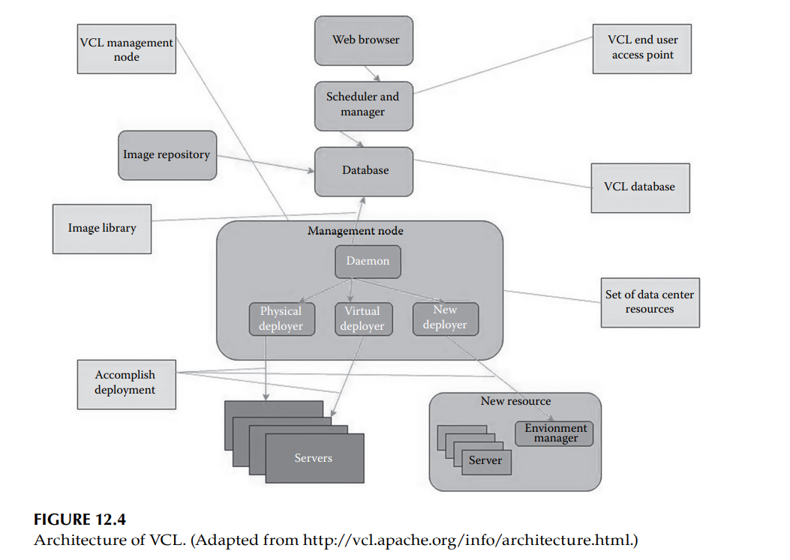

1. **Google Drive**

Google Drive is a file storage and synchronization service provided by Google that enables user cloud storage, file sharing, and collaborative editing. Files shared publicly on Google Drive can be searched with web search engines. Google Drive lets the user store and access files anywhere—on the web, on the hard drive, or on the go. It works as follows:  
• Go to Google Drive on the web at drive.google.com.   
• Install Google Drive on the computer or mobile device.  
• Store files in Google Drive. It is available on the device from which it is accessed. After doing so, user will be able to access files from anywhere he or she wants to. If a file is changed on the web, by using a computer, or a mobile device, it is updated on every device where Google Drive is installed.

1. **Google Docs**

Another SaaS offering by Google is Google Docs. It is one of the many cloud-computing document-sharing services. The majority of document-sharing services require user fees, whereas Google Docs is free. Its popularity among businesses is growing due to its enhanced sharing features and accessibility.  
In addition, Google Docs has enjoyed a rapid rise in popularity among students and educational institutions. Google Cloud Connect is a plug-in for Microsoft Office 2003, 2007, and 2010 on Windows that can automatically store and synchronize any Microsoft Word document, PowerPoint presentation, or Excel spreadsheet to Google Docs in Google Docs or Microsoft Office formats. The Google Doc copy is automatically updated each time the Microsoft Office document is saved. Microsoft Office documents can be edited offline and synchronized later when online. Google Cloud Sync maintains previous Microsoft Office document versions and allows multiple users to collaborate by working on the same document at the same time.

1. **DropBox**

Dropbox is a file hosting service operated by Dropbox, Inc. that offers cloud storage, file synchronization, and client software. Dropbox allows users to create a special folder on each of their computers, which Dropbox then synchronizes so that it appears to be the same folder (with the same contents) regardless of which computer is used to view it. Files placed in this folder also are accessible through a website and mobile phone applications. Dropbox provides client software for Microsoft Windows, Mac OS X, Linux, Android, iOS, BlackBerry OS, and web browsers, as well as unofficial ports to Symbian, Windows Phone, and MeeGo. Both the Dropbox server and desktop client software are primarily written in Python. The desktop client uses GUI toolkits such as wxWidgets and Cocoa. Other notable Python libraries include Twisted, ctypes, and pywin32. Dropbox ships and depends on the librsync binary-delta library (which is written in C). The Dropbox client enables users to drop any file into a designated folder that is then synchronized with Dropbox’s Internet service and to any other of the user’s computers and devices with the Dropbox client. Users may also upload files manually through a web browser.  
Dropbox client supports synchronization and sharing along with personal storage. It supports revision history, so files deleted from the Dropbox folder may be recovered from any of the synced computers. Dropbox supports multiuser version control, enabling several users to edit and repost files without overwriting versions. The version history is by default kept for 30 days, with an unlimited version called Pack-Rat available for purchase. Dropbox also provides a technology called LAN sync, which allows computers on a local area network to securely download files locally from each other instead of always hitting the central servers.

**Submitted By:   
Amogh Garg  
2020UCO1688**